**Machine Learning Assignment**

**Simple linear regression:**

**ProblemStatement:**

For the data given below , find:

1. the line of best fit

2. the coefficient of determination

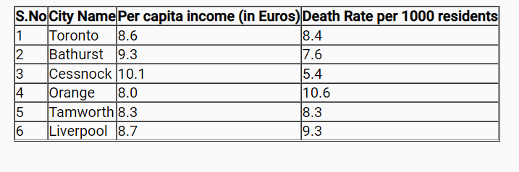

**SVM Model :**

1. Create an SVM model that classifies data into setosa and non-setosa on the iris data set using the features Sepal Length and Sepal Width as predictors. Check the prediction statistics of the model using a two way table.
2. Plot the margin lines and the hyperplane for the SVM model that classifies iris data into setosa and non-setosa with a cost = 0.01

Hint: The SVM model created exposes the coefficients (w), support vectors (x) and the b intercept. Refer help to figure out how you can extract them

**Implementation of kNN:**

1. Consider "iris" data set

There are 150 observations in "iris" data set whose class is already know. With the help of this data, kindly try to predict the class of the of the following data points.

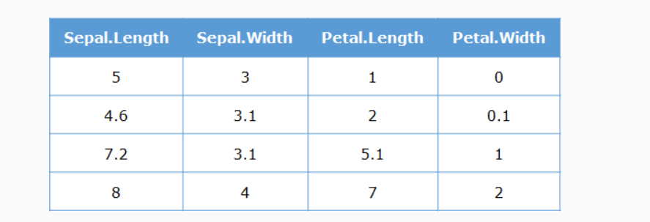

Also, calculate the prediction accuracy for k=(1,2,3,4), given that the first two data points belong to "setosa" class and the last two data points belong to "virginica" class.

1. **Implement KNN algorithm using following data set link**

<https://gist.github.com/nstokoe/7d4717e96c21b8ad04ec91f361b000cb>